Project #3 Multi-cycle Processor and Assembler
(CS152B – Summer 2004)

Members Group #4
Ho, Hing Kei
Vega, Javier
Yu, Wei Jun
Date: 08/11/2004
Background and Specification

This project involved the construction of a multi-cycle CPU using a mixture of schematics and VHDL programming language. The CPU needed to implement a set of instructions (ISA) provided by the specification of the project. The ISA included operations of the type: Arithmetic, Bitwise, Logical, Stack, Data Transfer, Conditional Branch, Function call and Unconditional Jump; a total of 22 instructions.

The CPU has 16 bit words and needed to be installed in the board to test the programs written for the constructed architecture. The specifications involved the use of a 16-bit ALU, a register file and a memory module as basic component, and the use of control unit module that would be processing the instructions code provided. Additional to these components, the specifications included the construction of a stack component to support functions of the type push and pop.

The instruction set architecture included 3 basic types of instructions: R-type, I-type and J-type. All these instructions were implemented using similar data paths when their specification was similar and of similar constructions.

The specification also involved the construction of an assembler compiler for the ISA and the CPU just built. The assembler needed to support many options like labels, “defines” statements, and other detailed in the specs requirements.

High Level Design for Parts 1-3

Part: 1

The Multi-Cycle CPU

Basically, the CPU was constructed using 5 main components: Register File, ALU, Memory, Program Counter and Control Unit. These components were connected according to the data path needed to make everything work according the specs provided in the project description.

As main component, the control unit is the module that controls all the data paths and signals for the specific operations to be executed. The control unit would fetch the instruction according to the program counter memory location, starting at memory location 0 from the memory component, and interpret that operation. Then the program counter would get increased and the next instruction would get fetch for execution. The control unit was design in VHDL.

The ALU needed to be modified from the previous project to support a new operation, an arithmetic shift, which for shift left or right it would needed to maintain the most significant bit to be consistent with the sing of the number in the ALU.

The register file was kept the same as for project 2, needed no modification of further test to check its operation.

The memory module was also kept the same, without any modification needed for its correct operation with the CPU.

The PC was built using an register, the same of the one used for building the register file.

Here it is a diagram of the overall CPU:

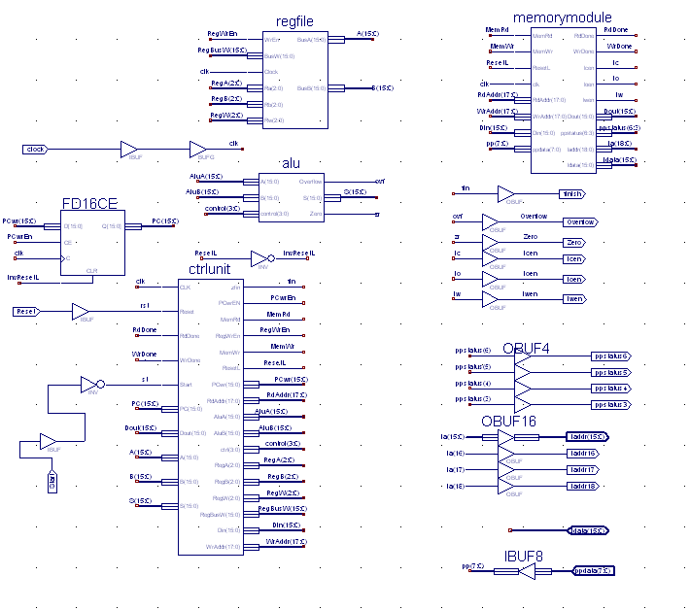

Here the main components of the design are illustrated, with the addition of the input/output signals for the appropriate operations. Our design included the use of a button for starting the execution of the CPU and a reset signal for starting the board using one of the dip switches. We also use one of the led lights in the board to identify when the execution of the program was terminated, verifying the we got to the last operation of the code: the halt instruction.

One of the challenges that we had to face was the coordination of all the modules by the control unit. First, we assumed that the memory address was read from position 0, increasing words by count of 1. So the subsequent memory address for the upcoming instruction would be added 1. However, we find out that the memory works as multiple of 2, because it stores two words of 8 bits in one addressable position. This was the first problem we found, and then we had to increase the program counter by 2 every time we executed the next instruction to get the CPU working correctly. Another challenged that we had with the CPU was the testing and debugging because it was really hard to find out whether the control unit was working fine with the model simulator, we had to use the board and test the program that way to find out if it was working or not. To do that, we used temporary instructions to store debugging results of executing simple operations.

Part: 2

The Assembler

The assembler fully implements the specifications given in the project handout. It was written in Java (to take advantage of its rich string library), and it is called asm2hex. It can be run from the command prompt, with the first argument being an .asm input file (the assembly code) and the second argument being the .hex output file (the machine code in hex). It also takes an optional third parameter “-debug” to run the program in debug mode. In other words, to call the program from the command prompt, type:
java asm2hex input.asm output.hex [-debug].

In addition to translating assembly code line-by-line, the assembler also supports Define directives, labels, and comments. It accomplishes this by making two passes on the code. The first pass performs syntactic analysis – checking for misspelled words, missing commas, unmatched parentheses, etc – and classifying each instruction as I-type, R-type, or J-Type. At this point, operands could be either numbers or labels. Labels are simply temporary placeholders for now; they will be replaced by numerical values later in the second pass. This means that the first pass also must associate each label with a value, which will replace the corresponding label later.

Finally, the second pass performs the actual label lookup and translation. For each label, we look up the value we obtained from the first pass. If we cannot find the label we want, then we know we have an undefined label, and the assembler outputs an error.

The assembler can also be run in debug mode by including “-debug” as a third argument. The debug mode was added to help debug both the development of the assembler itself as well as the translation of assembly code to machine code. In debug mode, the assembler outputs some extra information. In addition to outputting the code in hex, it also outputs a binary representation and the instruction type.

The challenges that we had to face with the assembler were related to the use of the PC counter as well. Originally the PC counter was increased by 1, which caused misbehave the compiled code to be tested. After fixing that problem, another problem appeared, which was to fix the labels location related to the memory location of the program stored. After that, the assembler worked very well.

As of the advantages of our assembler is that it was written in Java, which makes it very portable, and very easy to understand, modify and maintain. Also, we added an option for debug the compiled code to view exactly if the assembler was outputting the code correctly to be interpreted by the board. After all those problems were fixed, the assembler worked smoothly.

Part 3:

Putting it all together

To test the project, we first created a sample code to be compiled:

addi r6, r0, 5
sw r6, 48 (r0)
hlt

This code was the first thing we wanted to test, if the CPU could read and write to the memory properly. Once we tried this simple code in the board and it worked fine we proceeded with more complex code samples.

The testing process was composed of compiling the code with the Java program to a .hex file. Then we loaded the code in the board using the commands to load a file, starting at memory address 0. Then we reset the board and select the button to execute the code. After the program was ran we check to see if the results were the expected.

As of challenges with testing all the components we didn’t have many, except for the tedious task of recompiling code many times and then testing it in the board, by loading the file first and clicking the buttons. Rather than that, everything else was straight forward.

The other programs used for the testing of the code, were the Fibonacci sequence and a sort type of sequence.

Here it is the sample code used for both programs:

Fib:

addi r6, r0, 1 ;r6 = 1
addi r4, r0, 13 ;r4 = n
addi r1, r0, 1 ;int a=1
addi r2, r0, 1 ;int b=1
addi r3, r0, 3 ;int i=3
for: slt r5, r4, r3 ;if n<i, r5=1
beq r5, r6, endFor ;if r5=1, goto endFor
add r5, r1, r2 ;int c = a + b
add r1, r2, r0 ;a = b + 0
add r2, r5, r0 ;b = c + 0
inc r3, r3 ;i++
sw r2, 40(r0)
j for

endFor: sw r2, 40 (r0)
hlt

Insert Sort:

Define arraySize 8
Define Addr 48 ; 48..54
Define Dest 56 ; 56..62
addi r1, r0, 0
addi r2, r0, 0
addi r4, r0, 8
for: slt r5, r1, r4
beq r5, r0, done
lw r5, Addr(r0)
sw r5, Dest(r1)
addi r7, r0, 0
for2: slt r6, r2, r4
beq r6, r0, done2
lw r5, Dest(r1)
lw r6, Addr(r2)
slt r3, r6, r5
beq r3, r0, nocopy
sw r6, Dest(r1)
addi r7, r2, 0
nocopy:
addi r2, r2, 2
j for2
done2:
addi r6, r0, 10
sw r6, Addr(r7)
addi r2, r0, 0
addi r1, r1, 2
j for
done:
hlt

Implementation Details of Part 1:

The implementation details of the project are similar to those in project 2.

ALU:
The top-level multiplexer is controlled by a control unit, which maps the ALU operation to the correct select signal for the mux. This control unit is implemented in VHDL, taking ALUCtrl(3:0) as inputs and outputting a two-bit selection bus to the mux. The VHDL code simply consists of three if statements, conditioning on ALUCtrl(3:0).

The add, logical, and shift modules each take in three input buses: A(15:0), B(15:0), and ALUCtrl(3:0). Each unit produces a 16-bit result. In addition, the arithmetic module and shift module each outputs an overflow signal. Since an ALU overflow occurs if either overflow is high, we fed them into a two-input OR gate. But since ALU overflow is not possible for two’s complement, less-than, and the two logic operations, we should ensure overflow is always disabled for those operations. That was the motivation for creating the overflow-enable module, which takes ALUCtrl(3:0) as input and outputs an enable signal for only the appropriate operations. The overflow enable signal and the output from the two-input OR gate are fed into a two input AND gate, to produce the ALU overflow signal. The overflow enable module was also designed in VHDL, and consists of simple if statements conditioning on ALUCtrl(3:0).

The project specifications also called for a Zero signal, to be raised when S = 0. This can be accomplished through a simple VHDL module. It is basically an if-statement conditioning on S, and the module raises the Zero signal if it sees S = 0.

The logical module was implemented in VHDL and was straightforward. Taking A(15:0), B(15:0), and ALUCtrl(3:0) as inputs, it decides whether to do an AND or an OR operation on the data buses based on the control bus, and outputs the result.

The shifter was implemented entirely in VHDL as well. It takes A(15:0), B(3:0) and ALUCtrl(3:0) as inputs and outputs an overflow line and a 16-bit data bus. The shifting was implemented on a case-by-case basis, based on the op code and on the shift amount specified in B(3:0). For each shift operation – logical left, logical right, arithmetic left, arithmetic right – the VHDL code lists all sixteen possible B(3:0) values, and for a specific shift position, lists all sixteen output bits. Additionally, the shifter must detect overflow, which happens when the last bit shifted out is a one. Thus the overflow signal of the shift module is equivalent to the last bit shifted out.

The most complex module is the arithmetic module, which was designed in schematic with the help of some VHDL modules. At the heart of the arithmetic module is the ADSU16 adder/subtracter. It provides services to all operations which use the arithmetic module. Each of the two inputs of the ADSU16 is selected by a mux. The first mux selects from A(15:0) and a 16-bit zero-bus (a bus of all zero signals), while the second mux picks from a 16-bit one-bus (a bus with all zeros except the least significant bit), B(15:0), and the inverted value of A(15:0).

For the add and subtract operations, the first mux selects A(15:0) and the second mux picks B(15:0). The ADSU16 has an input signal to specify either add or subtract. For increment and decrement operations, the first mux selects A(15:0) and the second mux picks the one-bus. In the case of a two’s complement operation, the first mux selects the zero-bus, and the second mux picks the inverted values of A(15:0) and set the carry-in for the ADSU16. This emulates the steps of inverting A and adding one to get the two’s complement of a number. For a less-than operation, the first mux chooses A(15:0) and the second mux picks B(15:0) and the ADSU16 is told to subtract. To completely implement the less-than operation, we needed a separate module to detect a negative ADSU16 result. This negative detection module was done in VHDL, and it takes as input the output of the ADSU16, A(15), B(15) and the ALUCtrl(3:0). The module determines whether the result was negative by looking at the most significant bit of the result from the ADSU16. However, this approach would only work if no overflow occurs, but we are not guaranteed that since A(15:0) subtract B(15:0) possibly produces overflow. That is the reason for also feeding in the A(15) and B(15) signals. If A(15) = 1 and B(15) = 0, we automatically know that A < B without looking at the result from the ADSU16. Similarly if A(15) = 0 and B(15) = 1, then A > B.

The design also includes a module to detect general overflow of the arithmetic unit. This unit was designed with VHDL and accomplishes overflow detection by examining A(15), B(15) and the MSB of ADSU16 result. It is able to detect the four possible overflow cases, as listed below.

Operation | A | B | Result
Add | Positive | Positive | Negative
Add | Negative | Negative | Positive
Subtract | Positive | Negative | Negative
Subtract | Negative | Positive | Positive

Schematic diagram of alu.sch
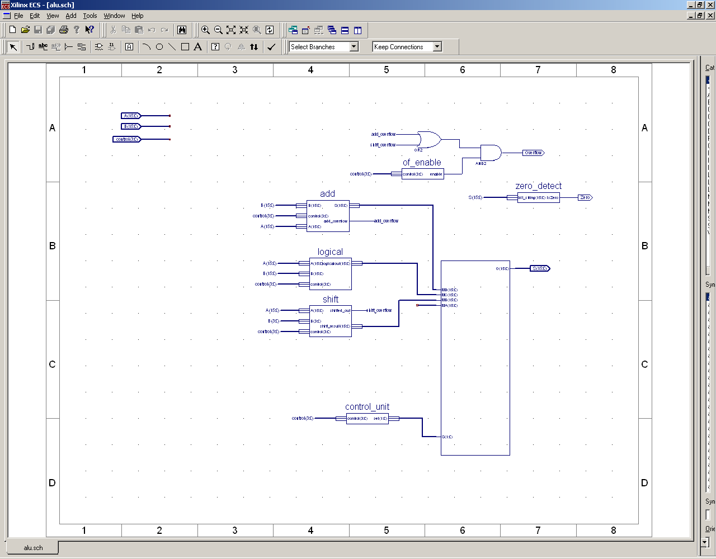
Schematic diagram of add.sch
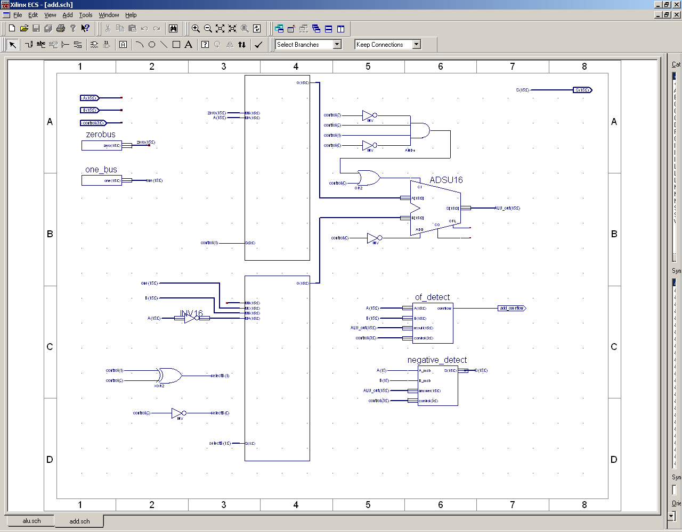

Register File:

The registry file was implemented in schematics to follow the specs indicated in the project sheet. Most basic component were required to implement the design and only one component was needed to be adapted using the CORE tool provided by the design tool. The component was a MUX that received 8 Buses of width 16 bits and selected only one to be outputted. That component was easily constructed following basic procedures from the tutorial 2. There is additional component that was used to store the data, which was the FD16CE which is a non volatile registry with a bus width of 16 bits. In our design we used 7 of those registry to store the 7 values required and we avoided to use one to store the registry 0. We connected the bus of registry 0 to ground making its output always zero.

Sample schematics of Registry File Implementation:

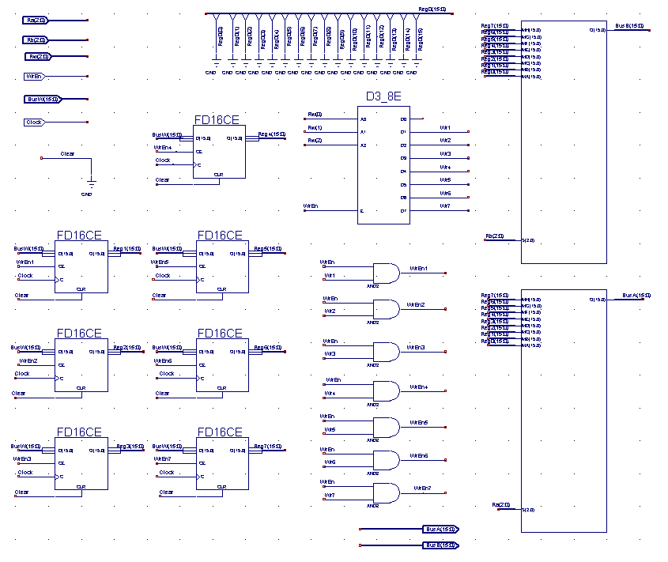

The connection of the design was very straight forward and can be looked at the schematics. There are 2 Muxes that select the values to be read, there are 7 registers that store the values, there is one Demux that is used select the register component that needs to write the data, and a few and gates with input/output connectors. All the registers have their input bus connected to the BusW bus signal, but the writing of the bus is selected with the Demux component that uses the value from Rw to select which register to write. The output of the registers goes to each one of the two Muxes which have connected the values from RA and RB busses to select which output to choose from. There are few gates used to select which register to write, but that is done only due to prevent writing to more than one registry in the cases of multiple clock cycles with changing values of WrEn, which can be observed on the schematics.

Memory Module:

The state machine of the memory read interface (memoryread.vhd):

State: stIdle
State: stDoRead1
DoRead = 1
State: stDoRead2
/ReadDone = 1
CanRead = 0
CanRead = 1
CanRead = 0
CanRead = 1
IssueRead = 0
IssueRead = 1

This design would communicate with the Sraminterfacewithsupport-sv02.vhd and follow the protocol stated in the specification.
Similarly, the state machine of the memory write interface (memorywrite.vhd):

State: stIdle
State: stDoWrite1
DoRead = 1
State: stDoWrite2
/WriteDone = 1
CanWrite = 0
CanWrite = 1
CanWrite = 0
CanWrite = 1
IssueWrite = 0
IssueWrite = 1

Also, this design would exchange signals correctly with the Sraminterfacewithsupport-sv02.vhd and follow the protocol stated in the specification.

In my design of these state machines, it was assumed that the write or read operation would be issued only after the previous one was done. However, a write operation or a read operation might still be issued simultaneously even when the SRAM was busy. Since the IssueWrite and IssueRead signals only went high for one cycle, the first states of my state machines were used to save the read or write command and wait for the SRAM to be free. In this way, a write operation and a read operation could be issued at the same time.

At the top level of the memory module, the three components, memoryread.vhd, memorywrite.vhd and Sraminterfacewithsupport-sv02.vhd, were wired together as designed in the high level diagrams shown above. In my design, RdAddr, WrAddr, Din and Dout were directly wired to ReadAddr, WriteAddr, WriteData and ReadData respectively to simplify the logic inside the memory module. To convert the 18 bits input address to the SRAM 19 bits address, zeros were added to the ReadAddr(18) nad WriteAddr(18). For other signals, they were connected to their corresponding pins.

Control Unit Module:

The control unit module was basically built using VHDL to handle all the instructions fetch, execute, and start/reset process as well as coordinating all the components and data paths needed. The control unit is the most important part of the CPU and its functioning was the key part of getting the project to work successfully.

The control unit was design to support all the instructions specified in the ISA and to update the data path required to each of the subcomponents in the CPU. The ALU, memory module, Register File and the Program Counter are being managed by the Control Unit.

The control unit input/output signals were named accordantly to the data that they connect, so the understanding of the signals is very intuitive and self-explanatory.

The control unit was built with the basic input/output signals described in the following diagram:

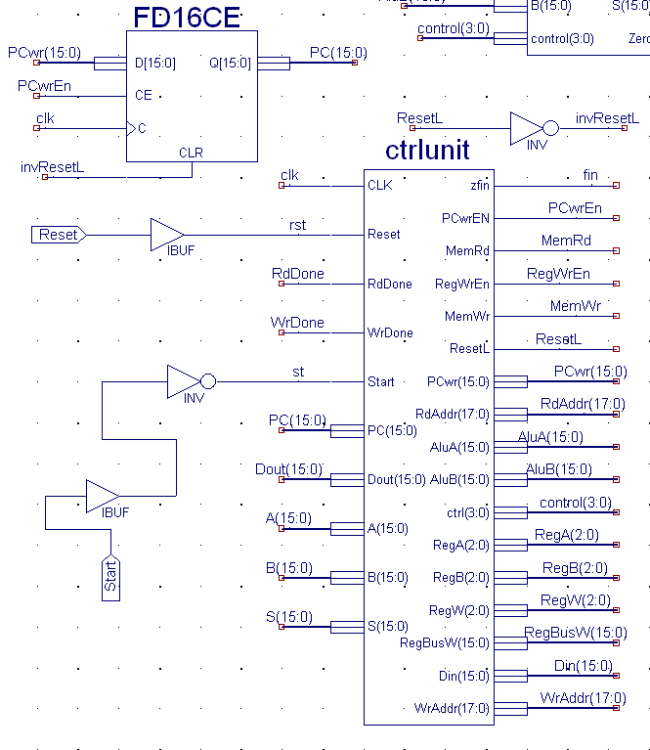

Here the start, and reset signals are inputs from outside of the board, the dip switch and the button, therefore they need the IBUF components. As of the other signals, the clock, RdDone, WrDone, PC, Dout, etc… are all very intuitive. The output signals are also named accordantly to where they connect and their functions.

The Internal coding of the Control Unit was made of two main processes:
The process that resets the board and sets the unit to idle, and the process that executed the instructions until it finds a halt instruction.

The first process was very simple and no more than 20 lines of code. It only set the values for the reset option or it updated the state to next state on the clock cycle.

The second processes was composed of 4 main parts: State IDLE which was used to start the execution, stPCtoSRAM, which was used to read the instruction from memory using the PC value to determine the address, the identification of Instruction Ready and the process of Instruction Implementation.

The instruction implementation was the one that would select which instruction to execute according to the op code given by the instruction to be read. The instructions were separated to common use of components to simplify the reuse of code and make the design very simple. The instructions were grouped according R, I and J type, which can be seen in the code of the Control Unit.

After a instruction was executed, the program counter was updated and the next state was to read from the memory the instruction.

Here it is a diagram of the state machine implemented:
stIDLE
StPCtoSRAM
stInstrImplmnt

stInstrReady

This is a very simple design of the basic functioning of the control unit, because our real implementation included more states. The states specific for certain instructions like: Push, Pop, Lw, Sw, Jal, and Jr. The reason for this is because those instructions require the access to memory, either for read of write so being more complex we decided its include them into its own states.

Example:

stInstReady
stPush
stPCtpSRAM

In this state diagram we can see that the state stPush also goes back to itself when waiting for the memory to be written. In this case it is the signal WrDone that needs to go high in order to complete the operation for the push call. The same is the case for the other mentioned instructions that need access to the memory to perform their tasks.

One the last instruction is found, which is one of the type halt, the control units loops for ever in the halt state and it waits for a new signal of start to execute again the code. When the halt state is reached on the of the led lights on the board is turned on.

Size of Design:

Slice Count
All together : 742 out of 768 → 96%
ALU alone : 185 out of 768 → 24%
Memory Module alone : 188 out of 768 → 24%
Register file alone : 124 out of 768 → 16%
Control Unit alone : -- out of 768→ --%

Details of Programming to the Device:

Programming the device was a process of 4 parts:

1 – Write the code
2 – Compile the code
3 – Execute the code
4 – Check the results

The first process involved writing the program in assembler code with the ISA described in the project specs. This process was pretty hard because of the limited number of registers used in the CPU, so it was required to save registers accordantly and restore them for the process. Also this task was hard because of the simplicity of the executing instructions for comparing number and branching according to the results of the comparisons.

Compiling the code was strait forward by executing the command line:

Java asm2hex source.asm dest.hex

And then the destination hexadecimal file was created.

The execution of the code was simple, it required the use of loading the hexadecimal code to the memory and then restart the unit and press start. To load the file we used the command:

loadf 0 dest.hex

And the program was loaded into memory.

To test the program results, we stored the results of the execution in a memory location of the program, so we could check the number. For example in the Fibonacci sequence calculation, we hard coded the number to be calculated into the hexadecimal code and then we executed the program having the expected results in a specified memory location.

A similar process was used to sort values, we tested basically the sort of an array specified in the code the position of the array, the size of the array and the address where the resulting values would get stored. After executing the code, we proceed to check for the results by reading that memory locations.

The reading and writing of specific values to memory was performed using the commands dump and write provided with the interface board.

The demo used was with the two main coded programs: FIB and ISORT, which are illustrated as follows:

Fib:

addi r6, r0, 1 ;r6 = 1
addi r4, r0, 13 ;r4 = n
addi r1, r0, 1 ;int a=1
addi r2, r0, 1 ;int b=1
addi r3, r0, 3 ;int i=3
for: slt r5, r4, r3 ;if n<i, r5=1
beq r5, r6, endFor ;if r5=1, goto endFor
add r5, r1, r2 ;int c = a + b
add r1, r2, r0 ;a = b + 0
add r2, r5, r0 ;b = c + 0
inc r3, r3 ;i++
sw r2, 40(r0)
j for

endFor: sw r2, 40 (r0)
hlt

Insert Sort:

Define arraySize 8
Define Addr 48 ; 48..54
Define Dest 56 ; 56..62
addi r1, r0, 0
addi r2, r0, 0
addi r4, r0, 8
for: slt r5, r1, r4
beq r5, r0, done
lw r5, Addr(r0)
sw r5, Dest(r1)
addi r7, r0, 0
for2: slt r6, r2, r4
beq r6, r0, done2
lw r5, Dest(r1)
lw r6, Addr(r2)
slt r3, r6, r5
beq r3, r0, nocopy
sw r6, Dest(r1)
addi r7, r2, 0
nocopy:
addi r2, r2, 2
j for2
done2:
addi r6, r0, 10
sw r6, Addr(r7)
addi r2, r0, 0
addi r1, r1, 2
j for
done:
hlt

The execution of the first program was to calculate the Fibonacci sequence of a number, we tried several numbers with the correct results, as they were showed to the TA on the demonstration of the program.

For the second program, we stored 4 numbers less than 10 on a selected memory address, then we executed the sort program to sort those number in the following memory locations with the correct expected results. This was also shown to the TA in the demonstration of the project in class.

Simulation Results:

As of simulation of specific parts of the program we created some special test cases for the parts that could not be demonstrated to the TA in the demo of the project. This parts were the use of certain instructions like: Push, Pop, Jal and Jr.

As follows:

The results of Push:

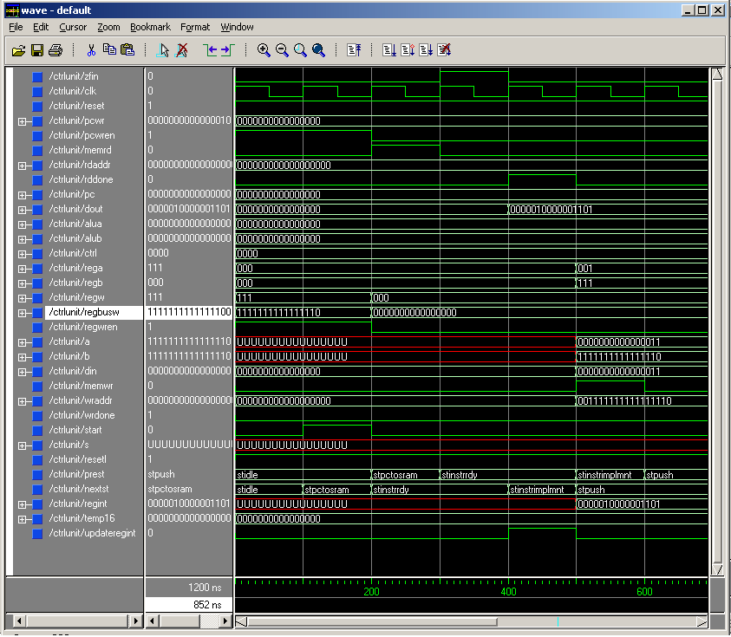

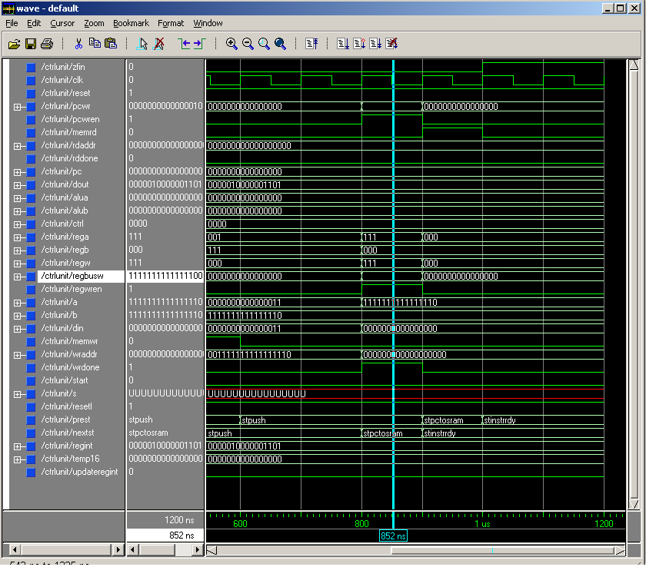

In this two wave forms we can appreciate the functioning of the control unit when executing the instruction push. The change of states are the correct with the memory read/write operations and the control signals for the PC counter and other units are also correct. The .do file associated with this wave form is: controlunit_push.do.
Results from testing Pop instructions:

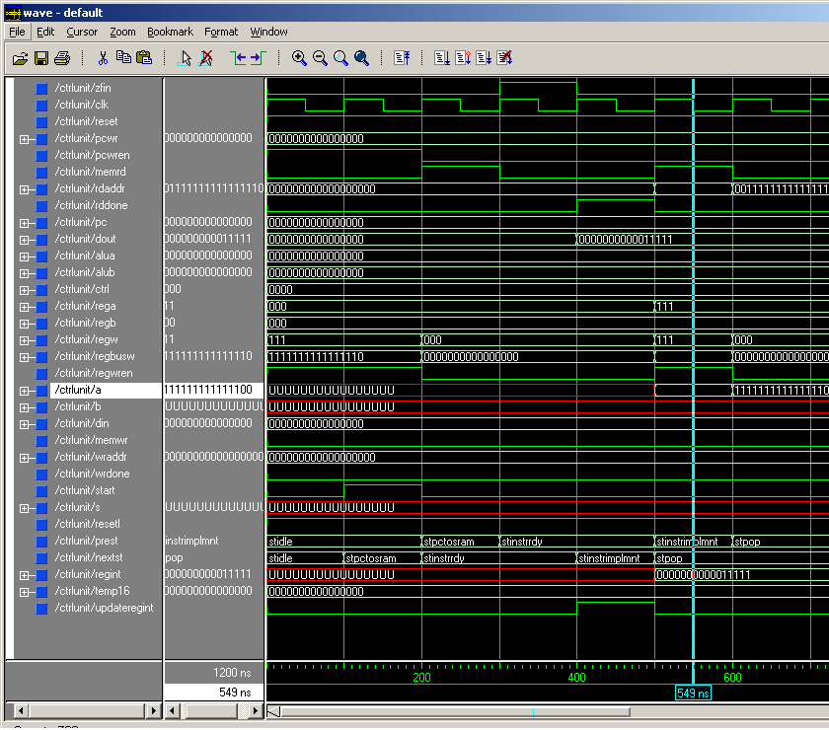

In this wave form we can illustrate the functioning of the control unit in the use of the instruction pop. The change in the states is given in the /crtl/regint/ value that changes from state to state indicating the correct functioning of the instruction. Also, the additional values of the control unit required to perform a pop instruction from memory and the stack pointer values are also being properly set.

The following image illustrates the additional control unit signals.

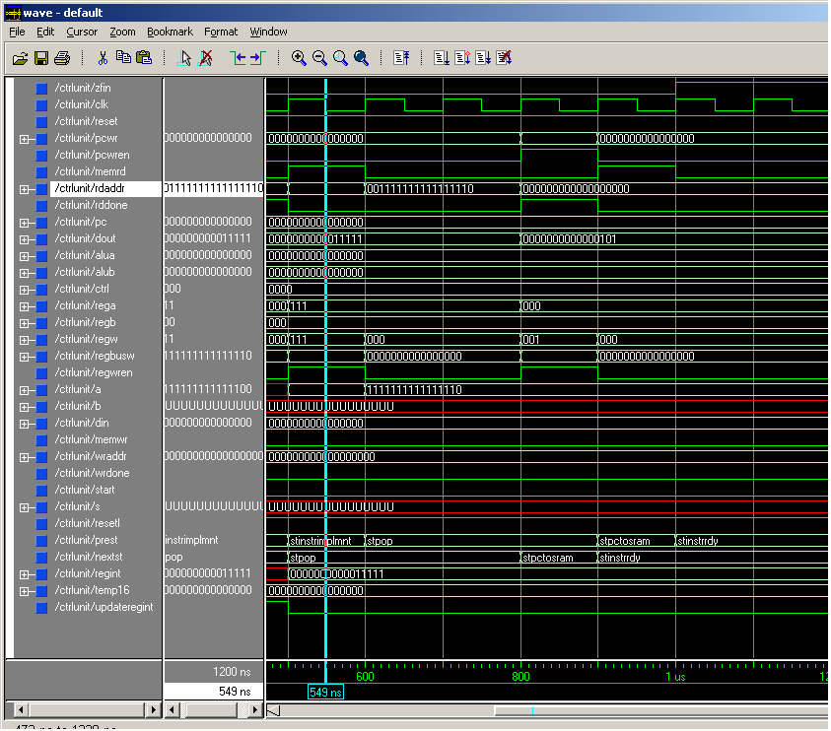

The .do file associated with this wave form is: controlunit_pop.do.
Results from testing Jal instructions:

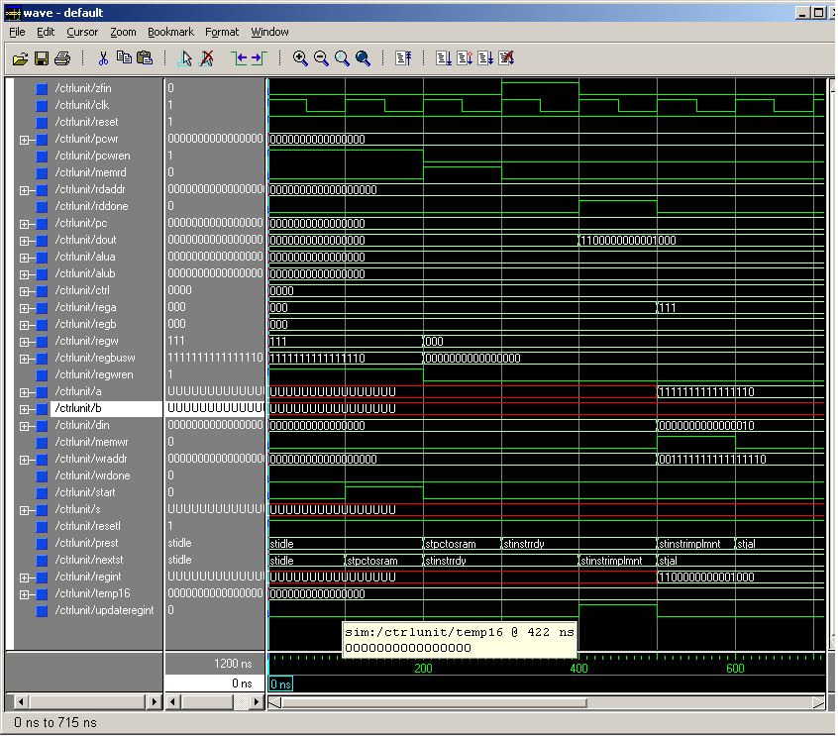

This waveform image shows the correct functioning of the JAL instruction and the properly set of the values that the control unit sets. The program counter, the state machine of the control unit, the registers and the additional values get also correctly set.
The values selected by the cursor and the highlighted ones also show the correct state.

In the following waveform we see the continuation of those values being properly set.

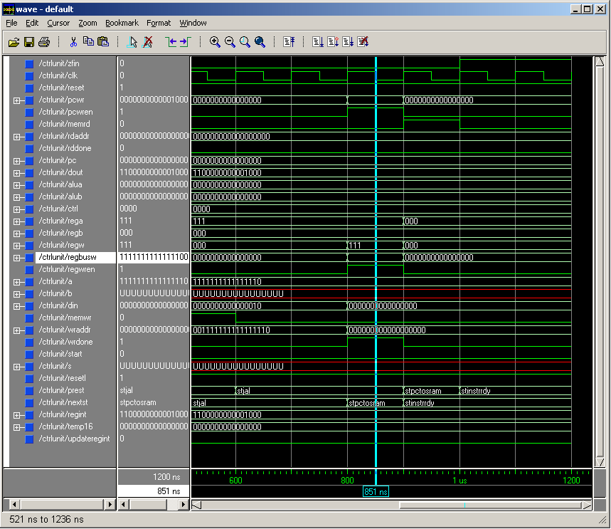

The .do file associated with this wave form is: controlunit_jal.do.
Results from testing JR instructions:

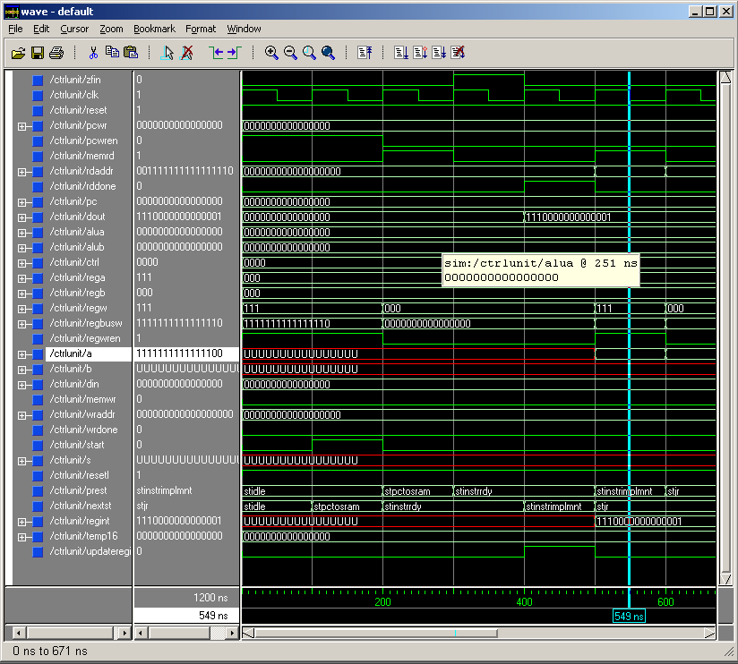

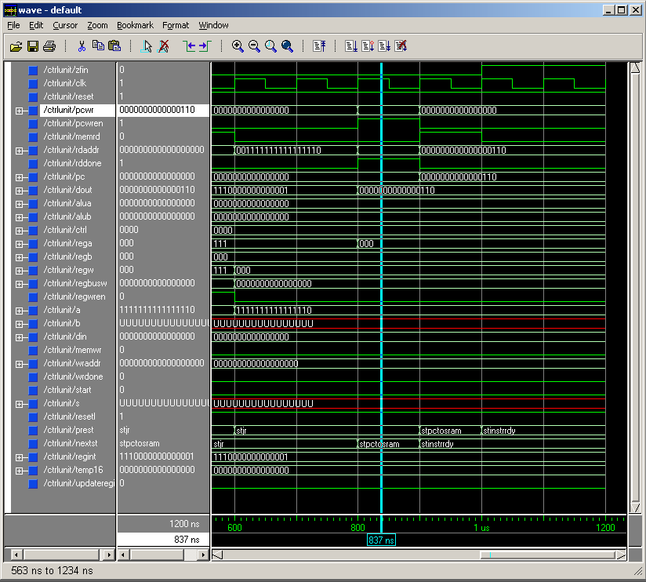

The .do file associated with this wave form is: controlunit_jr.do.
Division of Tasks

Hingkei:
Main CPU design, help writing assembler code, performing testing waveforms, and debugging main CPU design.

Wei:
Help with CPU design and debugging, writing compiler for assembler in java and debugging it. Writing the Fibonacci program and testing.

Javier:
Debugging, CPU design support, Writing and debugging insert sort, write report and help debugging assembler compiler.

